Project Design Phase-I
Solution Architecture

Date | 25 October 2026
Team ID | Individual
Project Name | EV Market Analysis
Maximum Marks | 4 Marks

Solution Architecture:
Solution architecture is a complex process – with many sub-processes – that bridges the gap between business problems and technology solutions. Its goals are to:
- Find the best tech solution to solve existing business problems.
- Describe the structure, characteristics, behavior, and other aspects of the software to project stakeholders.
- Define features, development phases, and solution requirements.
- Provide specifications according to which the solution is defined, managed, and delivered.

Solution Architecture Diagram:
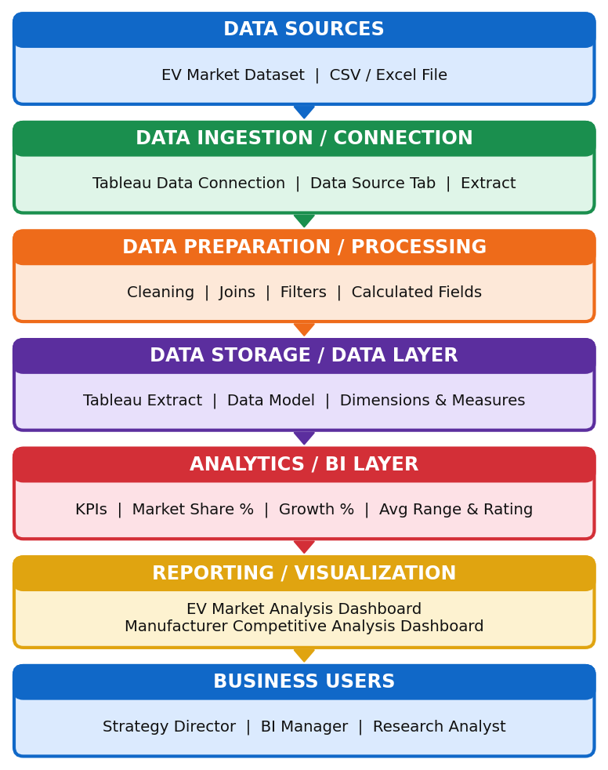

Component Description Table
Component Name | Description / Role in Architecture | Technology Used
EV Market Dataset | Source of EV records: sales units, battery type, range, rating, category, manufacturer, manufacturing country, model year | CSV / Excel file
Data Connection | Connects the dataset to the analytics tool and loads it for analysis | Tableau Data Connection (Data Source tab)
Data Preparation | Cleans fields, joins data and creates calculated fields such as market share % and growth % | Tableau Desktop (calculated fields, filters)
Data Storage / Extract | Stores the prepared data as a fast extract and data model for all worksheets | Tableau Extract
Analytics / BI Layer | Calculates KPIs: total sales, CO2 prevented, market share, average range and rating, sales growth | Tableau calculations and measures
Visualization Layer | Presents interactive dashboards: EV Market Analysis and Manufacturer Competitive Analysis, with Mapbox map | Tableau Dashboards (Mapbox maps)
Business Users | Strategy Director, BI Manager and Research Analyst use filters and charts to make decisions | Tableau Desktop / Tableau Public

